Akorn

### PROJECT REPORT

### Submitted by

**BHARATH KUMAR M** (Reg no: MJAWMCA012)

### In Partial Fulfillment of requirements For the award of the Degree of

### MASTER OF COMPUTER APPLICATION (MCA)



### CENTRE FOR COMPUTER SCIENCE AND INFORMATION TECHNOLOGY

### University Of Calicut MANJERI JULY 2023

**ACKNOWLEDGEMENT**

The success of the project depends upon the effort invested. It’s my duty to acknowledgement and thanks the individuals who have the contributed in the successful completion of the project. First and foremost, I praise the God Almighty for the grace he showered on me during my studies as well as day to day life activities.

I take this opportunity to express my profound and wholehearted thanks to **Ms. Shalini NP** (Associate Coordinator, CCSIT Manjeri) for providing ample facilities made to undergo my project successfully. I express my heartfelt gratitude to our internal guide **Mr. Rinshad . K** (Assistant professor, CCSIT Manjeri) for their constant encouragement throughout the course of study. They have taken pain to go through the project and make necessary correction as and when needed. I am also thankful to my department faculties for their continuous motivation for the successful completion of my project.

I wish to express my love and respect for my parents, for their support, contribution and encouragement which helped me a lot to complete this project successfully. I finally give a bunch of thanks to my friends and all my well-wishers who had supported me directly and indirectly throughout the project with their constructive criticisms.

**DECLARATION**

I hereby declare that this submission is my own work and that, to the best of my knowledge and belief, it contains no material previously published or written by another person or material which has been accepted for the award of any other degree or diploma of the university or other institute of higher learning, except where due acknowledgment has been made in the text.

|  |  |
| --- | --- |
| Date: | Signature: |
| Place: | Name. : **BHARATH KUMAR M** |
|  | Reg. No.: MJAWMCA012 |

**CERTIFICATE**

This is to certify that the project report entitled Akorn submitted by Bharath kumar M (Register Number: MJAWMCA012) to University of Calicut for the award of the degree of Master of Science (MCA) in Computer Application is a bonafide record of the project work carried out by him/her under my supervision and guidance. The content of the report, in full or parts have not been submitted to any other Institute or University for the award of any other degree or diploma.

|  |  |
| --- | --- |
| Signature | Signature |
| Mr. Rinshad . K | Ms. Shalini NP |
| Assistance Professor | Associate Coordinator |

Place:

Date:

**PROJECT EVALUATION REPORT OF THE EXAMINERS**

Certified that the candidate was examined by us in the Project Viva Voce Examination held on ................................. and his/her Register Number is ..............................................

Examiners:

1.

2.

**ABSTRACT**

The "Akorn" is a dynamic and user-centric web application tailored to facilitate the realization of creative projects and innovative business ideas. The platform serves as a virtual launchpad, connecting visionaries and entrepreneurs with a global community of backers eager to support and invest in compelling ventures. The key components of the platform include project creation, funding goals, and backer rewards. "Akorn" is designed to be a catalyst for innovation, providing a digital ecosystem where creativity thrives and dreams find wings. By combining a user-friendly interface with robust features, the platform empowers creators to transform their ideas into reality while fostering a supportive community that believes in the power of collective impact.

**INTRODUCTION**

Welcome to **AKORN**, the visionary project incubator. In a landscape where innovation meets opportunity, **AKORN** stands as a beacon for dreamers and creators seeking to bring their boldest ideas to life. With a dynamic fusion of cutting-edge technology and community-driven support, **AKORN** redefines the crowdfunding experience, empowering both visionaries and backers alike to embark on transformative journeys together.

At the heart of **AKORN** lies a revolutionary platform designed to transcend the limitations of traditional crowdfunding systems. Gone are the days of generic project presentations and disconnected support networks. Instead, Akorn offers a vibrant ecosystem where creativity thrives and collaboration flourishes.

With **AKORN** innovative features seamlessly integrated, **AKORN** presents an unparalleled opportunity for creators to showcase their projects with unparalleled depth and detail. From captivating multimedia presentations to flexible funding goals tailored to individual project needs, **AKORN**’s comprehensive project creation interface empowers creators to captivate and inspire.

Transparency and accountability form the bedrock of **AKORN**’s ethos. Backers are granted real-time visibility into funding progress, ensuring a clear understanding of how their contributions propel projects towards success. With diverse funding options and personalized reward tiers, backers are invited to engage with projects on a deeper level, forging meaningful connections with the creators they support.

#### PROBLEM DEFINITION AND METHODOLOGY

**1. Problem Definition**

The Akorn project aims to establish a revolutionary crowdfunding platform to transform the traditional crowdfunding experience. This platform seeks to address several challenges present in current crowdfunding systems, particularly focusing on improving the connection between investors and entrepreneurs.

#### 2. Objectives

The primary objectives of the feasibility study for the Akorn project are:

* Assessing the technical feasibility of developing the Akorn platform, including infrastructure requirements, scalability, and integration capabilities with API’s.
* Conducting an economic analysis to determine the financial viability of the project, including initial setup costs, revenue streams, and sustainability measures.
* Evaluating operational feasibility by examining user experience, administrative processes, and platform management strategies.

#### 3. Motivation

The motivation behind launching Akorn lies in revolutionizing the crowdfunding landscape and to find investors as soon as possible

Akorn aims to unlock new possibilities for both creators and backers, facilitating the realization of innovative ideas through collective support and collaboration.

#### 4. Methodology

The feasibility study will employ the following methodology:

* **Technical Feasibility:** Assessing the capability of integrating API’s, infrastructure and developing a scalable platform with optimal performance and security.
* **Economic Feasibility:** Conducting a cost-benefit analysis to determine financial viability, revenue generation potential, and sustainability through transaction fees and premium features.
* **Operational Feasibility:** Evaluating user experience design, administrative processes, and backend systems to ensure efficient platform operation and management.
* **Legal Feasibility:** Ensuring compliance with regulatory requirements related to data protection, financial regulations, and intellectual property rights across jurisdictions.

#### 5. Scope

The feasibility study will focus on:

* Analyzing the technical requirements and capabilities necessary for developing and maintaining the Akorn platform.
* Evaluating operational feasibility by examining user interface design, project management tools, and community engagement features.
* Addressing legal considerations to ensure compliance with relevant laws and regulations governing crowdfunding platforms.

**Feasibility Study**

The feasibility study assesses the viability of implementing the Akorn project. This study evaluates various aspects, including technical, economic, operational, and legal feasibility, to determine the project's potential success.

1. **Technical Feasibility**

* Platform Development: Developing the Akorn platform requires advanced web development skills, including front-end and back-end development, database management. API’s and existing infrastructure provides a strong foundation for technical implementation.
* Scalability: The platform must accommodate a growing user base and increasing project submissions without compromising performance. Scalability measures, such as cloud-based infrastructure and optimized code, are necessary to ensure seamless operation.

1. **Economic Feasibility**

* Cost Analysis: The project involves initial development costs, including software development, infrastructure setup.
* Market Potential: The demand for crowdfunding platforms is significant, with an increasing number of entrepreneurs and creatives seeking funding for innovative projects. Akorn's unique features and user-centric approach position it favorably in the market.

1. **Operational Feasibility**

* User Experience: Akorn's success depends on providing a seamless and intuitive user experience for both creators and backers. Operational feasibility hinges on the platform's ability to facilitate project creation, funding managemen.
* Administrative Processes: Effective management of user accounts, project submissions, and financial transactions is essential for operational success. Streamlined administrative processes, supported by robust backend systems, ensure smooth platform operation.

1. **Legal Feasibility:**

* Regulatory Compliance: Compliance with relevant regulations, such as data protection laws and financial regulations, is critical to operating a crowdfunding platform. Legal feasibility requires thorough adherence to legal requirements in all jurisdictions where Akorn operates.
* Intellectual Property: Protecting intellectual property rights for project creators and ensuring compliance with copyright laws is essential to mitigate legal risks and maintain trust within the community.

**Conclusion:**

The feasibility study indicates that the Akorn project is technically, economically, operationally, and legally feasible. With proper planning, execution, and ongoing management, Akorn has the potential to become a leading crowdfunding platform, fostering innovation, creativity, and meaningful connections among creators and backers.

### **Requirement Analysis and Specification**

#### Requirement Analysis/Literature Review

The requirement analysis for the Akorn project involves assessing the needs and expectations for a crowdfunding platform based on the MERN stack (MongoDB, Express.js, React, Node.js). This includes reviewing existing literature on crowdfunding platforms, analyzing user expectations, and understanding technological advancements in web development.

#### Existing System

Current crowdfunding platforms often lack personalized project presentations, and seamless integration these limitations hinder user experience and project success rates.

#### Proposed System

The proposed Akorn system aims to revolutionize crowdfunding by leveraging the MERN stack's capabilities:

* **MongoDB:** Provides a scalable and flexible NoSQL database solution for storing diverse data types related to projects, users, transactions, and comments.
* **Express.js:** Offers a robust backend framework for building RESTful APIs to manage project creation, user authentication, transaction handling, and communication between the client and server.
* **React:** Facilitates dynamic and interactive user interfaces with reusable components, enhancing user experience and engagement.
* **Node.js:** Powers the backend server environment, enabling efficient handling of concurrent requests, real-time updates, and integration with external APIs.

#### Requirement Specification

##### a. Functional Requirements

1. **User Management:**
   * Registration and login with email or social media accounts.
   * Profile management for creators and backers.
   * Role-based access control for administrators, creators, and backers.
2. **Project Management:**
   * Project creation with multimedia presentations (images, videos, text).
   * Flexible funding goals.
   * Real-time visibility of funding progress and backer interaction.
3. **Financial Transactions:**
   * Dummy payment gateway integration for transactions.
   * Compliance with financial regulations and data protection laws.

##### b. Non-functional Requirements

1. **Performance:**
   * Response time optimization for seamless user interaction.
   * Scalability to handle increasing user traffic and project submissions.
2. **Security:**
   * Encryption of sensitive data (user credentials).
3. **Usability:**
   * Intuitive user interface design for easy navigation and project discovery.
   * Accessibility features to accommodate diverse user needs.

##### c. Environmental Details (Hardware & Software Requirements)

* **Hardware:** Standard servers or cloud-based infrastructure to host MongoDB, Node.js server, and frontend React application.
* **Software:** Operating systems compatible with Node.js (e.g., Linux, Windows), MongoDB database management system, and development tools like Visual Studio Code for coding.

#### Feasibility Study

##### a. Technical Feasibility

Assessing the technical feasibility involves evaluating the capability of the MERN stack to meet project requirements, including platform scalability, integration with external APIs and deployment on chosen infrastructure (cloud or dedicated servers).

##### b. Economical Feasibility

Conducting a cost-benefit analysis to determine initial setup costs (development, infrastructure), ongoing operational expenses (maintenance, server costs), revenue generation through transaction fees, and profitability projections based on market demand and growth potential.

##### c. Operational Feasibility

Evaluating the operational feasibility by analyzing user experience design, administrative processes (account management, project submission review), and backend system management (database administration, server monitoring) to ensure efficient platform operation and management.

**REQUIREMENT ANALYSIS AND SPECIFICATION**

**Modularity Criteria and User Interface Layout**

Designing the user interface (UI) layout for Akorn's platform involves several key considerations to ensure usability, engagement, and effectiveness. Here’s a structured approach to defining the UI layout:

**Header**

- Logo: Clearly identifiable Akorn logo for brand recognition.

- Navigation: Intuitive menu options

**Hero Section**

- Eye-catching Banner: Featuring a compelling project or success story to attract attention.

- Call-to-Action (CTA) Buttons: Prominently placed buttons for creators to start a project and for backers to explore projects.

**Main Content Area**

- Project Categories: view of project categories for easy browsing.

- Featured Projects: Highlighted projects, brief descriptions, funding progress, and funding goals.

- Filters and Sorting Options: Enables users to filter projects and categories, etc.

**Project Details Page**

- Project Title and Description: Clearly defined with visuals and a compelling narrative.

- Creator Information:** Profile of the project creator(s), including their background and previous projects (if applicable).

**Footer**

- Contact Information: Links to contact support, FAQs, and customer service information.

- Legal Information: Terms of Service, Privacy Policy, and other legal disclosures.

**Design Principles**

- Responsive Design: Ensures compatibility and usability across various devices (desktop, tablet, mobile).

- Visual Consistency: Unified color scheme, typography, and iconography for a cohesive brand identity.

- Intuitive Navigation: Seamless navigation flow with clear hierarchy and intuitive user interactions.

**Users of the System**

In the context of Akorn, "Users of the System" refers to the various stakeholders or individuals who interact with and utilize the Akorn platform. These users typically include:

**1. Creators (Entrepreneurs or Visionaries):**

- Creators are individuals or teams who propose projects or business ideas on the Akorn platform. They use the system to create detailed project profiles, set funding goals, and interact with backers.

**2. Backers and Users (Investors or Supporters):**

- Backers are individuals or organizations interested in supporting and funding projects proposed by creators. They browse projects on Akorn, pledge funds to support projects they find compelling, and may receive rewards based on their contribution level.

**3. Administrators (Platform Managers):**

- Administrators are responsible for managing and overseeing the Akorn platform. They monitor project submissions, ensure compliance with platform policies, handle user support issues, and maintain the overall functionality and security of the system.

**Architecture Diagrams**

**a. DFD**

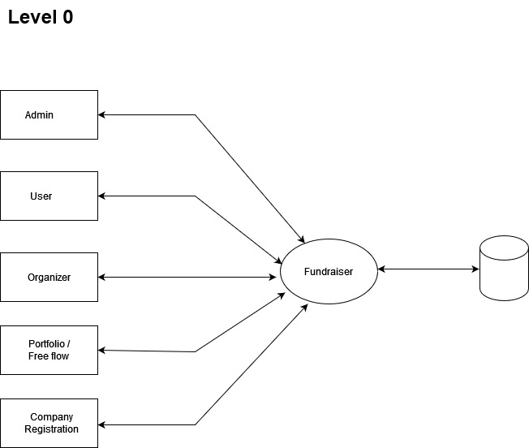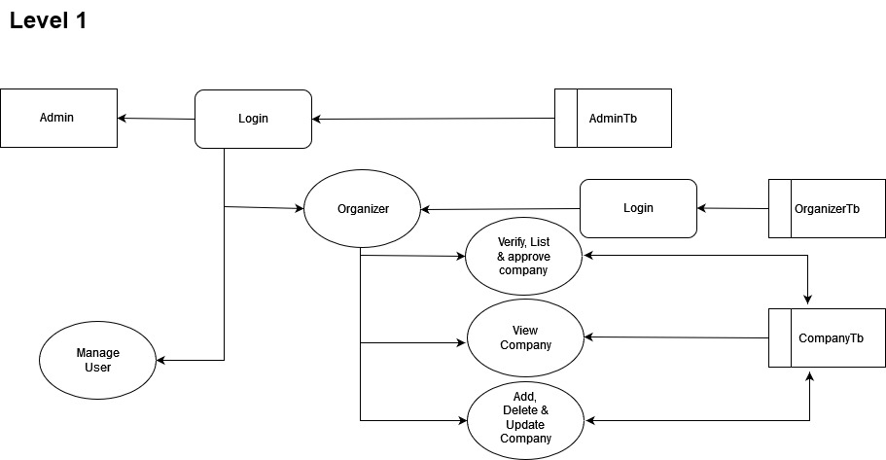

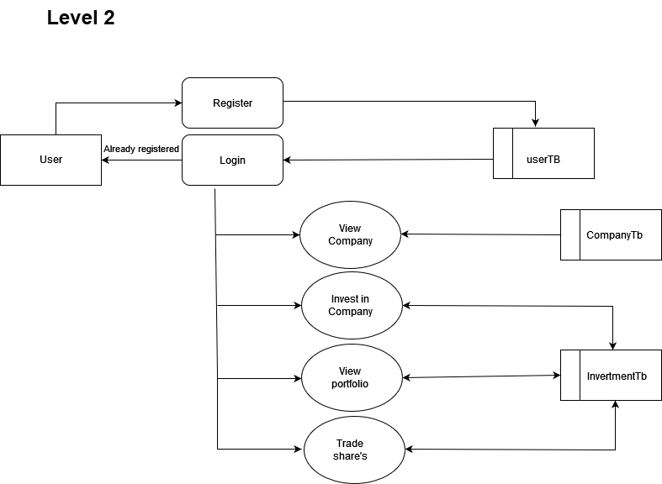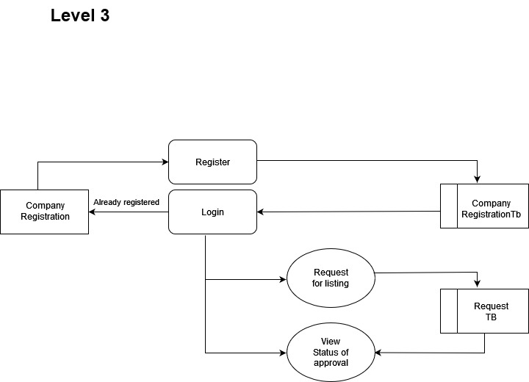

**b. Database Design**

**CompanyRegistration**

|  |  |  |
| --- | --- | --- |
| Column Name | Data Type | Notes |
| name | VARCHAR(255) |  |
| email | VARCHAR(255) |  |
| linkedin_founder | VARCHAR(255) | (Nullable) |
| linkedin_company | VARCHAR(255) | (Nullable) |
| sector | VARCHAR(255) | (Nullable) |
| market_cap | VARCHAR(255) | (Nullable) |
| address | TEXT |  |
| pan_number | VARCHAR(255) | (Nullable) |
| website | VARCHAR(255) | (Nullable) |
| previous_fundraising_rounds_discription | TEXT |  |
| product_discription | TEXT |  |
| traction | TEXT |  |
| revenue_and_making | TEXT |  |
| team_size | INT |  |
| community_fund_raising_reason | TEXT | (Nullable) |
| where_you_learn_about_us | TEXT | (Nullable) |
| existing_commitments | TEXT | (Nullable) |
| pitch | TEXT | (Nullable) |
| financials | TEXT | (Nullable) |
| amount_expected_to_raise | DECIMAL |  |
| excel | VARCHAR(255) | (Nullable) |
| status | BOOLEAN |  |
| lots | INT | (Nullable) |
| lotsOriginal | INT | (Nullable) |

**excelData**

|  |  |
| --- | --- |
| Column Name |  |
| company_id (FK) | References companyregistration._id (Likely) |
| quaters | Array of strings representing quarters |
| incomeExpenses | Array of objects with metric (string) and values (array of numbers) |

**Userkyc**

|  |  |
| --- | --- |
| Column Name |  |
| name | User's name |
| email | User's email (unique) |
| linkedin_url | User's LinkedIn profile URL |
| address | User's address |
| pan | User's PAN number |
| aadhar | User's Aadhar number |
| contact_number | User's contact number |
| whattsapp | User's whatsapp number |
| about_yourself | User's description |
| anual_income | User's annual income |
| bank_account_number | User's bank account number |
| bank_account_photo | URL or path to bank account photo |
| where_you_learn_about_us | How the user found the platform |
| existing_commitments | User's existing funding commitments |
| avatar | URL or path to user's avatar |
| ID_proof | URL or path to user's ID proof |
| Status | User KYC verification status (default: 'null') |
| createdAt | Timestamp of KYC document creation |
| updatedAt | Timestamp of KYC document update |

**lotsData**

|  |  |
| --- | --- |
| Column Name |  |
| companyId (FK) | References companyregistration._id (Likely) |
| companyName | Name of the company the user invested in |
| email | User's email (redundant, consider removing) |
| lots | Number of investment lots purchased by the user |
| amountInvested | Total amount invested by the user (default: 0) |
| createdAt | Timestamp of investment record creation |
| updatedAt | Timestamp of investment record update |

**investmentData**

|  |  |
| --- | --- |
| Column Name |  |
| companyId (FK) | References companyregistration._id (Likely) |
| lots | Number of investment lots |
| amount | Total investment amount |
| companyName | Name of the company |
| companySector | Company's industry sector |
| email | User's email (redundant, consider removing) |
| timestamp | Timestamp of investment record creation (singular) |

**UserWallet**

|  |  |
| --- | --- |
| Column Name |  |
| money | User's wallet balance |
| email | User's email (unique) |
| createdAt | Timestamp of wallet record creation |
| updatedAt | Timestamp of wallet record update |

**CompanyWithdrawals**

|  |  |
| --- | --- |
| Column Name |  |
| companyId (FK) | References companyregistration._id (Likely) |
| amount | Withdrawal amount |
| email | User's email (redundant, consider removing) |
| status | Withdrawal request status (default: "null") |
| createdAt | Timestamp of withdrawal request creation |
| updatedAt | Timestamp of withdrawal request update |

### **IMPLEMENTATION**

#### 1. Brief Description about the Tools/Scripts for Implementation

For developing the Akorn platform on the MERN stack, the following tools and scripts were utilized:

* **Tools:**
  + Visual Studio Code (VSCode): Integrated Development Environment (IDE) for writing and debugging code.
  + Node.js: JavaScript runtime for server-side execution.
  + Express.js: Backend web application framework for Node.js.
  + React: Frontend JavaScript library for building user interfaces.
  + MongoDB: NoSQL database for storing project data, user information, and transaction details.
  + Mongoose: Object Data Modeling (ODM) library for MongoDB and Node.js.
  + Axios: HTTP client for making API requests from the frontend to the backend.
  + JWT (JSON Web Tokens): Used for authentication and authorization.
* **Scripts:**
  + npm scripts for running development and production servers.

#### 2. Module Hierarchy

The Akorn platform is structured into several modules to ensure modularity and maintainability:

* **Backend Modules:**
  + User Authentication and Authorization
  + Project Management
  + Database Management (MongoDB with Mongoose)
  + API Routes (Express.js)
* **Frontend Modules:**
  + User Authentication (Login, Registration)
  + Project Creation and Management
  + Backer Interaction and Engagement
  + Responsive UI Components (React)

#### 3. Coding

Key components of the Akorn platform implementation include:

* **User Authentication:**
  + Implemented using JWT for secure token-based authentication.
  + Protected routes in Express.js to ensure authorized access to specific endpoints.
* **Project Management:**
  + CRUD operations for projects, including creation, updating, deletion, and retrieval.
  + Integration with MongoDB to store project details, images, videos, and funding information.
* **Frontend Development:**
  + React components for project creation forms, project listings, and backer interactions.
  + Redux for managing application state and handling asynchronous actions.
  + Axios for making API requests to the backend and updating UI components dynamically.

#### 4. Problems Encountered

During implementation, several challenges were encountered:

* **Complexity of MongoDB Schema Design:**
  + Addressed by carefully designing MongoDB schemas to accommodate nested data structures for projects, comments, and user profiles efficiently.
* **Deployment and Environment Configuration:**
  + Configuring environments (development, staging, production) and managing environment variables securely using dotenv and deployment scripts.
* **Handling Asynchronous Operations:**
  + Managed asynchronous operations using async/await in Node.js to ensure proper flow control and error handling, especially during database queries and API requests.

#### 5. System Design

Agile Model for Akorn Platform

**1. Agile Manifesto Principles:**

- Individuals and interactions over processes and tools: Emphasize collaboration between developers, stakeholders, and users to ensure continuous feedback and alignment with project goals.

- Working software over comprehensive documentation: Prioritize delivering functional increments of the Akorn platform, focusing on user stories and iterative development.

- Customer collaboration over contract negotiation: Engage stakeholders and end-users throughout the development process to validate features and ensure they meet expectations.

- Responding to change over following a plan: Adapt the project scope and features based on continuous feedback, market trends, and emerging technologies.

**2. Agile Practices and Akorn Implementation:\*\***

a. Scrum Framework:

- Roles:

- Product Owner: Represents stakeholders and prioritizes features based on business value.

- Scrum Master: Facilitates the team, removes impediments, and ensures adherence to Agile practices.

- Development Team: Cross-functional team members responsible for implementing features.

- Artifacts:

- Product Backlog: Prioritized list of features (user stories) based on stakeholder feedback and project goals.

- Sprint Backlog: Features selected from the product backlog for implementation during a sprint.

- Increment: Functional software developed within a sprint, potentially releasable.

- Events:

- Sprint Planning: Define sprint goals and select user stories for implementation.

- Daily Stand-ups: Daily meetings to synchronize activities, discuss progress, and identify any blockers.

- Sprint Review: Demonstration of completed features to stakeholders for feedback.

- Sprint Retrospective: Reflect on sprint outcomes, discuss what went well, what could be improved, and plan adjustments for future sprints.

b. Iterative Development:

- Implement features of the Akorn platform in short iterations (sprints), typically 1-4 weeks long, to deliver incremental value and gather feedback early.

c. Continuous Integration and Deployment (CI/CD):

- Automate testing and deployment processes to ensure new features are integrated smoothly into the existing platform.

- Conduct regular testing (unit tests, integration tests) to maintain code quality and ensure functionality meets requirements.

d. User-Centric Design:

- Prioritize user stories that enhance user experience (UX), such as intuitive navigation, responsive design, and personalized project recommendations.

e. Cross-Functional Teams:

- Foster collaboration between developers, designers, testers, and stakeholders to ensure a holistic approach to feature development and deployment.

**3. Agile Implementation Benefits for Akorn:**

- Flexibility: Ability to respond to changing market demands and user feedback.

- Transparency: Regular updates and demos foster transparency with stakeholders and users.

- Quality: Continuous testing and integration improve software quality and reliability.

- Customer Satisfaction: Early and frequent delivery of valuable features enhances user satisfaction and engagement.

**4. Challenges and Mitigation:**

- Scope Creep: Prioritize features based on business value and maintain a stable product backlog.

- Team Coordination: Daily stand-ups and sprint planning sessions ensure alignment and address any coordination issues promptly.

- Technical Debt: Regular refactoring and addressing technical debt during sprints to maintain code quality.

The Agile model enhances the development of the Akorn platform by emphasizing collaboration, iterative development, and responsiveness to user needs. By adopting Agile practices, Akorn can deliver a robust and user-centric platform that revolutionizes the experience.

This Agile model aligns with Akorn's goals of fostering innovation, enhancing user engagement, and ensuring transparency in project funding, making it well-suited for iterative and adaptive development.

### **TESTING**

This outlines the testing phase for the Akorn platform, encompassing test plans, unit testing, integration testing, system testing, and implementation changeover plans.

#### 1. Test Plans

The test plan for Akorn focuses on validating the functionality, performance, and reliability of the platform. It includes:

* **Testing Objectives:** Ensuring all features meet specified requirements.
* **Testing Scope:** Covering user authentication, project management and user interactions.
* **Testing Schedule:** Milestones for unit testing, integration testing, and system testing phases.
* **Risk Assessment:** Identifying potential risks and mitigation strategies during testing.

#### 2. Unit Testing

##### a. Test Items (Test Cases)

**Backend Unit Testing:**

* **User Authentication:**
  + Test case: Verify login with valid credentials.
  + Test case: Verify token expiration handling.
* **Project Management:**
  + Test case: Create a new project and validate database entry.
  + Test case: Update project details and verify database update.

**Frontend Unit Testing:**

* **User Interface Components:**
  + Test case: Validate form inputs for project creation.
  + Test case: Test UI rendering for project listings and user profiles.

#### 3. Integration Testing

Integration testing ensures that components of the Akorn platform work together seamlessly:

* **Backend Integration Testing:**
  + Test interaction between authentication middleware and API endpoints.
* **Frontend Integration Testing:**
  + Validate interaction between React components.
  + Test asynchronous behavior of Axios requests for data fetching and updating.

#### 4. System Testing

##### a. Test Items (Test Cases)

System testing validates the overall functionality and performance of the Akorn platform:

* **User Workflow Testing:**
  + Test user registration, login, and logout processes.
  + Test end-to-end flow from project creation to funding and update notifications.
* **Performance Testing:**
  + Assess platform responsiveness under varying user loads.
  + Test database query performance during peak traffic times.
* **Security Testing:**
  + Verify encryption of sensitive user data (password).
  + Test for vulnerabilities in authentication mechanisms and API endpoints.

**CONCLUSION**

The Akorn platform emerges not only as a technological innovation but also as a game changer when it comes to investment platform. Akorn is built using the MERN stack – MongoDB, Express.js, React, and Node.js and aims to change how creators interact with their backers in the crowdfunding space. In all its stages of development and implementation, Akorn has been driven by one vision: promoting transparency, nurturing creativity and ensuring a smooth user experience.

**Reflection on Objectives and Achievements**

From its early days, Akorn has sought to overcome limitations inherent in other platforms that provide crowd funding services by concentrating on achieving specific goals: creating secure authentication schemes and optimizing user interaction through smart UI/UX design. However, these goals were not merely achieved but exceeded with JWT used for safe user login being implemented successfully resulted in methods which are trouble free. The intuitive user interface that uses React sets new standards of user experience in this form of investment thus allowing any person irrespective of her/his background will be able to manage or create projects easily.

**BIBLIOGRAPHY**

• Patidar, S. (2020). **MERN Quick Start Guide: Build web applications with MongoDB, Express.js, React, and Node**. Birmingham, UK: Packt Publishing.

• Subramanian, V. (2019). **Pro MERN Stack: Full Stack Web App Development with Mongo, Express, React, and Node**. Berkeley, CA: Apress.

• Rauch, R., & Tolley, C. (2017). **Fullstack React: The Complete Guide to ReactJS and Friends**. Self-published.

• Wilson, E., & Larson, C. (2018). **MongoDB: The Definitive Guide: Powerful and Scalable Data Storage**. Sebastopol, CA: O'Reilly Media.

• Hettiarachchi, S. (2019). **React Design Patterns and Best Practices: Build easy to scale modular applications using the most powerful components and design patterns**. Birmingham, UK: Packt Publishing.

• Banker, S. (2019). **MongoDB Applied Design Patterns: Practical Use Cases with the Leading NoSQL Database**. Berkeley, CA: Apress.